THE VANILLA POD

Submitted in partial fulfilment of the requirements of the degree of

BACHELOR OF COMPUTER ENGINEERING

By

Anurag Kawade, 21102013

Atharva Jagtap, 21102059

Kartik Kanchan, 21102010

Mit Jain, 21102044

Guide:

Prof Vishakha Chaudhari

Project Coordinator Prof Bharati Khemani



Department of Computer Engineering

1. P. SHAH INSTITUTE OF TECHNOLOGY, THANE

(2022-2023)

A.P.SHAHINSTITUTEOFTECHNOLOGY, THANE

CERTIFICATE

This is to certify that the Mini Project 2A entitled “**The Vanilla Pod**” is a bonafide work of **“Anurag Kawade (21102013), Atharva Jagtap (21102059), Kartik Kanchan (21102010) and Mit Jain (21102044)”** submitted to the University of Mumbai in fulfillment of the requirement for the award of the degree of **Bachelor of Engineering** in **Computer Engineering.**

**___________________________ __________________________________ _____________________________**

Guide Project Coordinator Head of Department

Prof. V. K. Chaudhari Prof. Bharati Khemani Prof. S. H. Malave



1. P. SHAH INSTITUTE OF TECHNOLOGY, THANE

Project Report Approval for Mini Project-2A

This project report entitled ***The Vanilla Pod*** by ***SE-A-11*** is approved for the degree of ***Bachelor of Engineering*** in ***Computer Engineering***, ***2022-23***.

Examiner Name Signature

1.________________ _____________

2._________________ ______________

Date:

Place:

**Declaration**

We declare that this written submission represents my ideas in my own words and where others' ideas or words have been included, I have adequately cited and referenced the original sources. I also declare that I have adhered to all principles of academic honesty and integrity and have not misrepresented or fabricated or falsified any idea/data/fact/source in my submission. I understand that any violation of the above will be cause for disciplinary action by the Institute and can also evoke penal action from the sources which have thus not been properly cited or from whom proper permission has not been taken when needed.

-----------------------------------------

          (Signature)

Anurag Kawade (21102013)

-----------------------------------------

          (Signature)

Kartik Kanchan (21102010)

-----------------------------------------

          (Signature)

Atharva Jagtap (21102059)

-----------------------------------------

          (Signature)

Mit Jain (21102044)

Date:

**Abstract**

"The Vanilla Pod" is a small scale cake shop. Our website allows the customer to view and book cakes from this shop. Here, the customer can browse through a variety of cakes and order one as per need. The customer can customize his/her own cake as per their choice. The website eases out the choice for the customer by providing search option.

Html5 is used to provide to define each functioning element in the website. The framework and tabs of the website are easily laid out by html. CSS3 is used to create and format content structure. It is used to add colours, font properties, text alignment, images and its alignment and to provide positioning of various elements with the values being fixed, absolute, and relative.

**CONTENTS**

* 1. Introduction ........................……………………………..…………………………….…. 0
  2. Problem Statement, Objectives and Scope….......……………………..…..…….……….…0
  3. Architecture …………..……...……..……………………………………………............…0

1. Implementation .……..…….………...……………………………………………….......…0
2. Future Scope………………...………………………………………………………………0
3. Conclusion………………………………………………………………………………..…0

References ...................................................................................................................................0

LIST OF FIGURES

1.1 name of fig ....................................................................................................................0

2.2 name of fig ....................................................................................................................0

LIST OF TABLES

1.1 name of table ................................................................................................................0

2.1 name of table ................................................................................................................0

LIST OF GRAPHS

1.1 name of graph................................................................................................................0

2.2 name of graph…………………………….. ................................................................0

**INTRODUCTION**

The topic of our Mini Project-IA is ‘The Vanilla Pod’. The website is a web-based e commerce site for purchasing and viewing cakes in one place. Anyone can view the website and login to it to understand its features.

How it started?

The idea of the project struck our mind when Covid19 begun to emerge in almost whole world. When countries were shutting down and all the small business and shops were closing. So we decided to help one of our friend’s sister who started to face financial crises due to his cake shop got shut before few days of lockdown. We thought to make his business online as it also helped him to recover from his financial crises and earn more profits by use of technology. We simply thought of making a e-commerce website for his business. Our project was named as “The Vanilla Pod”. So the idea was to enable customers to shop from comfort of their home. This idea was also safe it prevented over-crowing in the shop and also protected the shop owner and customers form covid19 by delivering cakes and bakery products to customer’s doorstep by no contact delivery method which also gives safety to delivery person. So our website is developed in such a way that allows users to check for various cakes available at the online store and purchase online.

Why to use the website?

The website also allows the user to make a sign in page and use his/her login id to get access to the website main function. The project consists of list of Cakes and bakery products displayed in various categories. The user may browse through these items as per categories. If the user likes a product he may add it to his shopping cart. He may even pay through a credit card or cash on delivery. Once the user makes a successful transaction he gets a copy of the shopping receipt on his email id. User has also option for ordering custom cakes according to their requirements like cake’s flavour, size, and shape and so on. Thus the online Cake shopping project brings an entire cake shop online and makes it easy for both buyer and seller. The user interface is simple and easy to understand. The user can only through the cake catalogue to get a glimpse of the cake. The user also has the ability to review the cakes so that the new customers can get an idea about the cake. We also will also ensure to allow discounts to the customer who buys the cakes from our website on special occasions. The user can purchase various types of cake we offer like birthday cakes, wedding cakes, fondant cake, jar cup cake, cake balls and also custom orders. Our website will also have pictures of already ready-to-serve cakes. The flavour of cake can also be selected through this website. The website also provides the details about the cake ingredients.

Aim of the website?

So the main aim was to gain more profits and save expenses like electricity bill of the shop or maybe rent of the shop if the shop is taken on rent. We are using firebase to store the information of the customers with full privacy, also to store information about products and their prices. Our website front-end is designed using Html, Css, and JavaScript. The customer information will include Address, Name, Age, credit & debit card details on our server (only if customer permits). Then we will process deliveries with our delivery partner companies. We can take our business worldwide too by expanding our bakery industry abroad.

What are the advantages of using this website?

You can buy online birthday cakes, anniversary cakes, designer cakes, wedding cakes and much more. These versatile and multi-purpose items are perfect for every occasion. Deliveries at your doorstep have never been so convenient! With cake delivery services across major cities, your favourite cakes are sure to reach you. Ordering cakes online is hassle-free. Most people use online shops to order cakes because of the prices. Perhaps for the modern generation, convenience holds more value. It is why the younger generation is the ones that use online platforms for their needs.

**PROBLEM STATEMENT, OBJECTIVES AND SCOPE**

Problem statement: Through our website, we aim to design an online cake shop. The website offers the customers many different types of cakes. It allows the customers to filter through cakes for different occasions, and conveniently place an order

Objectives: Through this website, we aim to reach out to build a broad and committed customer base and developing a business model that brings in enough income to cover the expenses despite a potentially high level of waste. We aim to promote the website through social media handles, which can help more engagement through the website, which in turn means more growth of the business

Scope: This system helps customer’s to place orders through online also eases the workload on the staff of cake shop. This system will make things easier for staff as whole ordering process is done by customer only. It would be much more comfortable for the customers to have an online cake order. It would be hassle free for users as they can select the cake they want and make payment for it. Also it will reduce the purchasing time for customers.

**ARCHITECTURE**

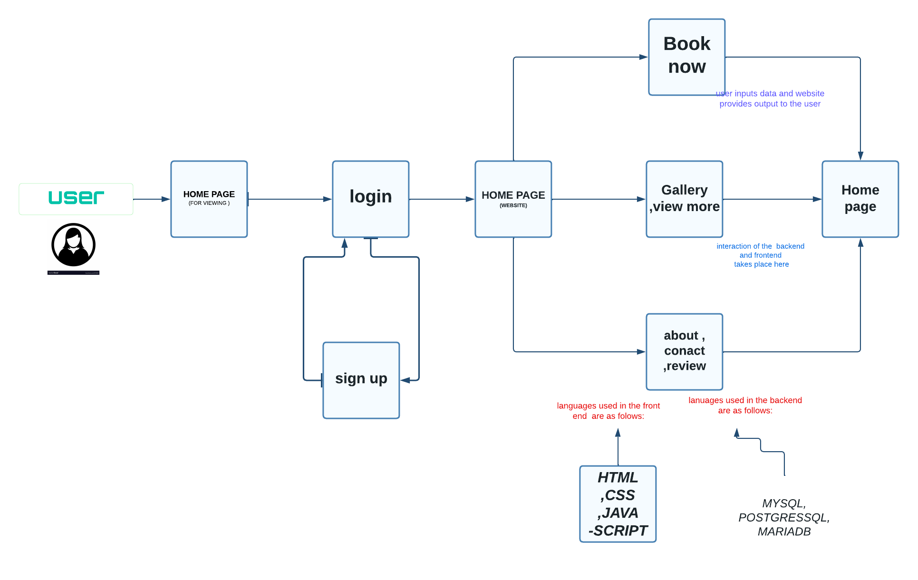

The user will first interact with the homepage which will then lead to the login and sign up page.

Further the user can decide if they want to book a cake and if not the user has the provision to surf the components which doesn’t need the user to login.

The user when logged in will have two options either to view the cake brochure and then book it or they can just view the brochure and add the cakes they like to the cart. User can order a custom product as per his favourite flavour, size, and shape

If the user have already signed in before the user can view the previous placed order and review them too. . The customer information will include Address, Name, Age, credit & debit card details on our server (only if customer permits). Then we will process deliveries with our delivery partner companies.

After All Product page there has an all categories button added in all categories there all bakery items like ‘Roll Items, Pastry Items, Biscuits Item, Cake Item, Birthday Cake, Toast Item, Snacks’ various item are available in our website. Lastly the ‘Contact Us’ page will provide the user with info of the creators of the website as well the email address through which they can send us their queries.

The User can locate the location of the cake shop on the website which is place in the footer. The Social Media handles provide extra information about the cakes and the baker. The review’s, likes and comments from the old user would be helpful to order and know about the cake.

In the backend html is used to design the skeleton of the page, this html is then further enhanced with the use of css. Forms in the website is made using javascript. When he places his/her order, an alert box is shown for the confirmation of the menu. After that the total amount will be shown and the user will be asked to enter the address to which he wants the food to be delivered. The address is mandatory and the user cannot proceed further without entering the address. For user’s safety purpose, the address is not saved in the database and the user will be asked to enter his address each time he makes an order. After that the Thank you page will be displayed and the user can either sign out or he can go back to the menu page and start a whole new order. Whichever option he chooses, the details from the previous menu will be erased for safety purposes.

**IMPLEMENTATION**

The implementation of the website is done to showcase of how various components about the website is functioning for a user

1. Homepage:

For a new user the website will have not all the functionalities as the user can only see the website but cannot order a cake. The user if wants to purchase the cake he/she has to sign up or login to do the further functionalities.

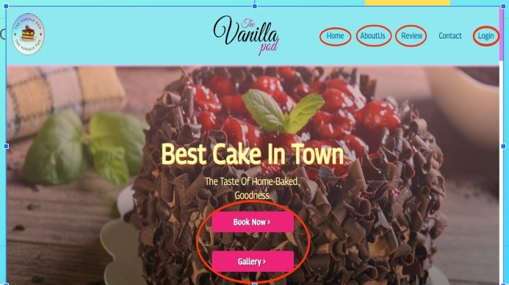

Main page of the website which consists of home, about us, review, contact, login, book now and gallery.

1. Login/ Sign Up:

Login system to store user email and encrypted password in the database. When a user logs in, the password is sent to the server where it is compared with the one in database. If they match, the user log in successfully. The user can login through Google and Facebook login.

Sign up system to collect and store mobile no, email id, DOB and encrypted password of new user in the database. Then if the user logs in with these credentials, then login will be successful.

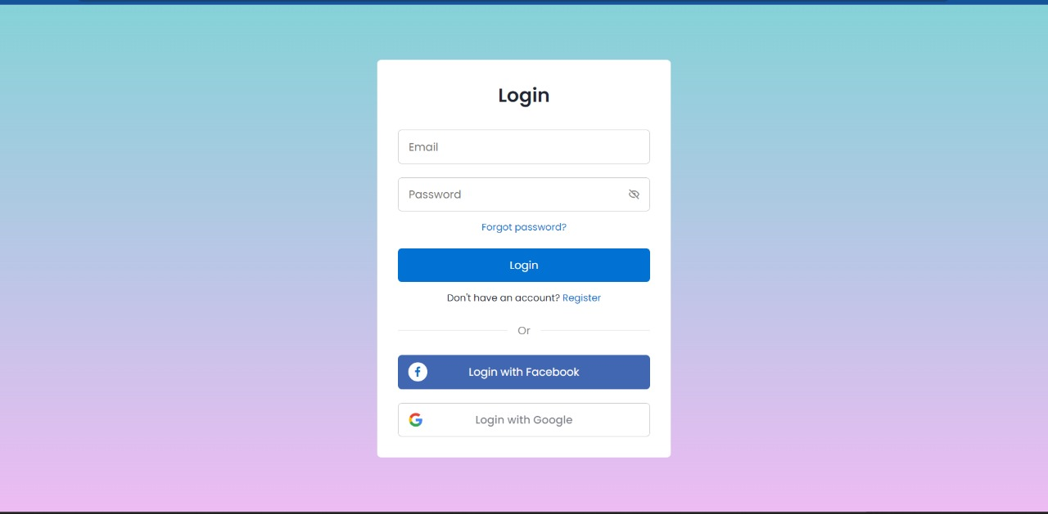

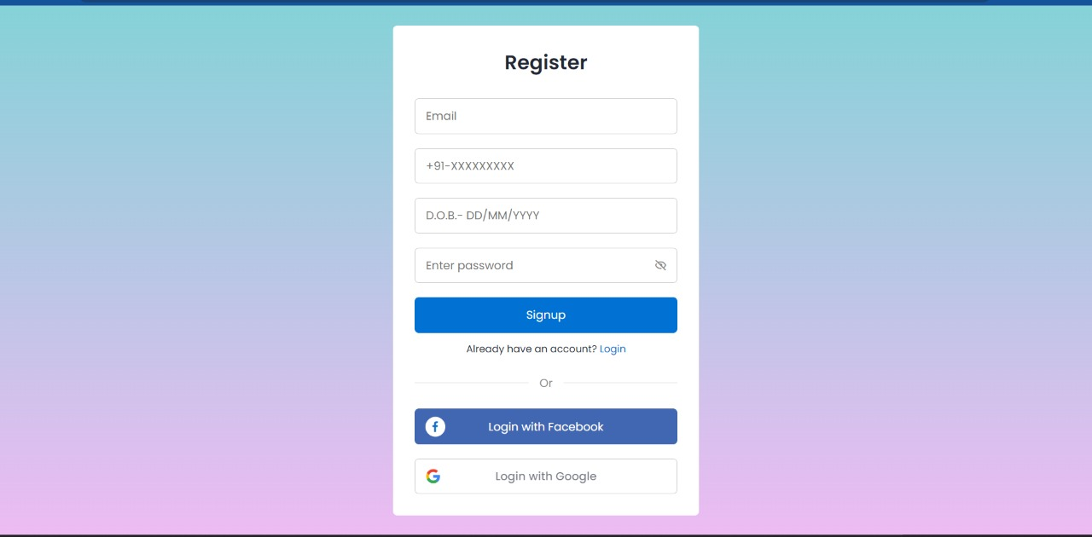

1. Gallery:

When the user goes through the website, after or without login in the website he /she goes through the website and has to by clicking the button , after that a new page pops on the screen which is connected to the website. And then it has a look the variety of the cakes that we have on our gallery which also has the category of types of cakes. This helps the user to know about the cakes as how they look and know some information about it. The user can expand its view.

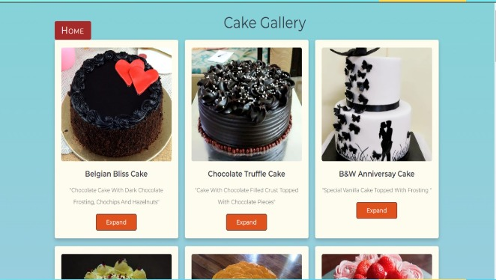

1. Cart/Book now:

After logging into the website, the user can browse through the gallery and find a desirable cake to order. Clicking the "Add to cart" button will place the selected cake int the cart.

Multiple cakes can be added be added here, which can be viewed with their price, from where the user can proceed to checkout.

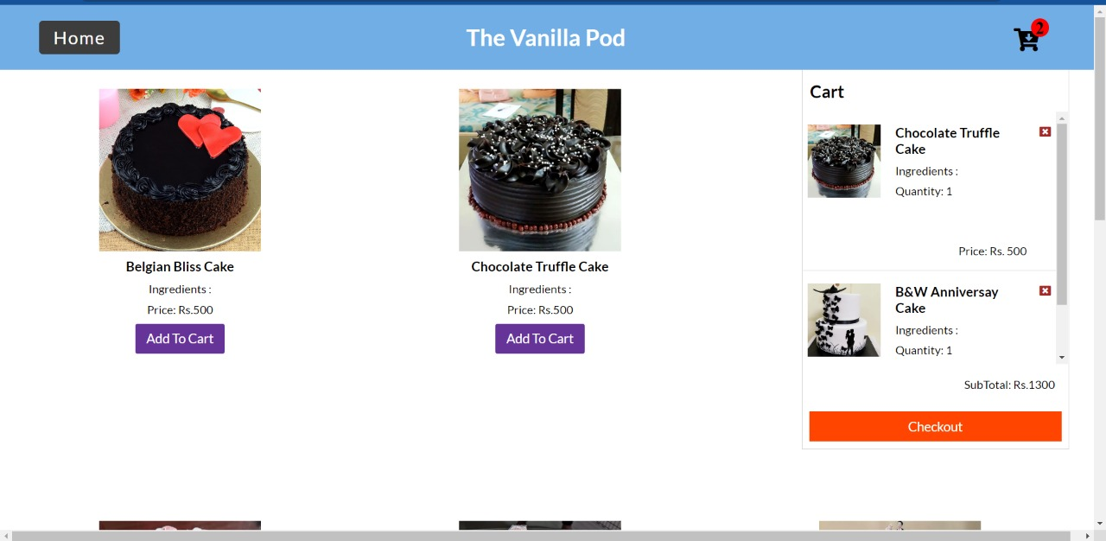

1. About Us:

The page allows the user to the story the cake shop it started and how it all started. The page also consists of social media links.

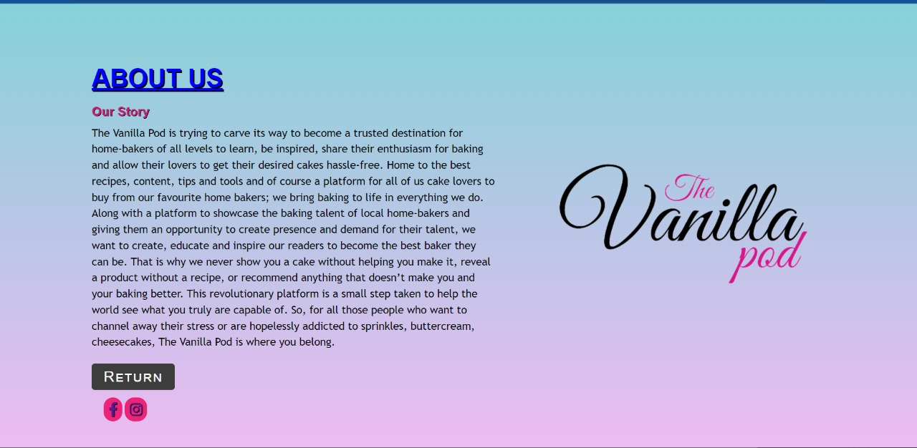

1. Footer:

The footer consist of various links of the bakery which used for the  promotion. It also consists of map which shows the location of the cake shop. The footer also links such as home, login, social media links, etc.

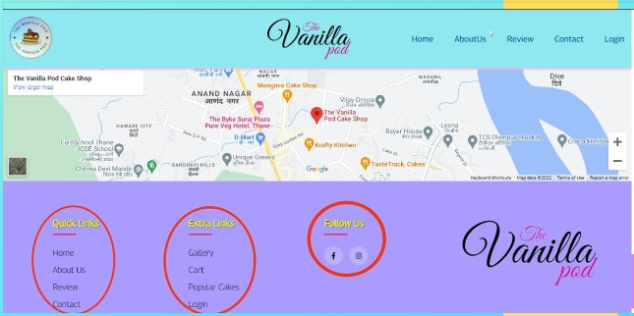

1. Review:

A review site is a website on which reviews can be posted about people, businesses, products, or services. These sites may use Web 2.0 techniques to gather reviews from site users or may employ professional writers to author reviews on the topic of concern for the site.

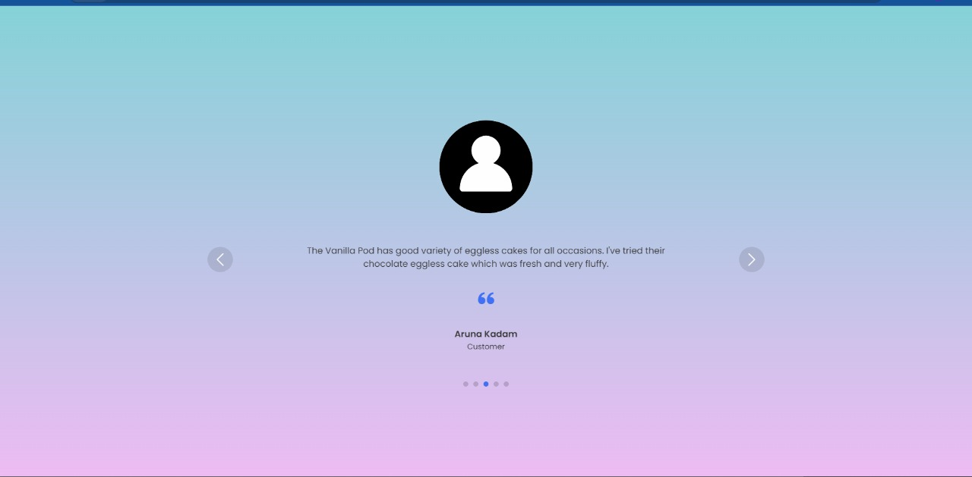

**FUTURE SCOPE**

People will be able to order our products form just comfort of their home. We have best present example of covid19, as most of the shops are closed & most of the people find bit risky to visit shops, Online shopping is convenient, easy, time saving, safe from customer’s point-of-view and from delivery executive’s point of view by providing no-contact-delivery. Our idea will boost cake & bakery businesses with low capital & more profits. Our Future plans for the website are firm the internet is growing day by day. With the ease our backend tool we can grow our website and increase our reach digitally. In future we can add more payments like UPI, net banking, debit/Credit Card, etc. We can add live order tracking which can show the status of an order and can show the delivery parcel if it is ready and on its way. It is sure that these kinds of website have a lot of scope in the near future as online.

**CONCLUSION**

This application is designed by keeping in mind the customer’s comfort. Now a days, because of the difficult life that people leaving, they do not have time to go to a restaurant, order food, pay for it, then wait for some more time to finally get their food. We’re committed to delivering your food. Our Delivery is right on time. We serve the fresh and the tastier cakes, bakeries at your doorstep in just 30 minutes.

**REFRENCE**

Book,

[1] J. F. Curtis, (Ed.), Processes and Disorders of Human Communication. New York: Harper and Row, 1978.

Journal Paper,

[2] J. Schroeterand M. M. Sondhi, “Techniques for estimating vocal-tract shapes from the speech signal,”IEEE Trans. Speech Audio Process., vol. 2, no. 1, pp. 133–150, 1994.

Proceeding paper,

[3]J. M. Pardo, “Vocal tract shape analysis for children,” in Proc. IEEE Int. Conf. Acoust., Speech, Signal Process., 1982, pp. 763–766.